Given the head of a singly linked list and two integers left and right where left <= right, reverse the nodes of the list from position left to position right, and return *the reversed list*.

**Example 1:**

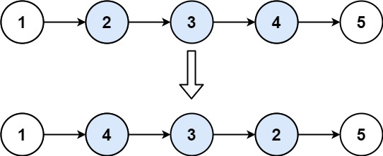

Input: head = [1,2,3,4,5], left = 2, right = 4  
Output: [1,4,3,2,5]

**Example 2:**

Input: head = [5], left = 1, right = 1  
Output: [5]

**Constraints:**

* The number of nodes in the list is n.
* 1 <= n <= 500
* -500 <= Node.val <= 500
* 1 <= left <= right <= n

**Follow up:** Could you do it in one pass?